# Chapter 27: CDO Structuring of Credit Risk

## Demonstrate knowledge of collateralized debt obligations (CDOs)

CDO structure has several variations, including B/S CDO, arbitrage CDO, and market value CDO;

* Describe the history of CDOs

1980: CDOs born, to place a portfolio of high-yield bonds into CDO structure to serve as its collateral and to issue securities (tranches) against that collateral

Major motivations for structured products

1. Risk management: Investors may be better able to manage risk through structured products.

2. Return enhancement: Investors may be better able to establish positions that will enhance returns if the investor’s market view is superior.

3. Diversification: Investors may be better able to achieve diversification through structured products

4. Relaxing regulatory constraints: Investors may be able to use CDO structures to circumvent restrictions from regulations

5. Access to superior management: Investors may obtain efficient access to any superior investment skills of the manager of the CDO

6. Liquidity enhancement: Tranches of CDOs can be more liquid than the underlying collateral pool

* Describe the general structure and life cycle of a CDO

In most CDOs, there is a three-period life cycle

1. **Ramp**-**up** **period**: CDO issues securities (tranches) and uses proceeds from CDO note sale to acquire the initial collateral pool (assets)
2. **Revolving** **period**: actively manage the collateral pool for COD, potentially buying and selling securities and reinvesting the excess cash flows received from CDO collateral pool
3. **Amortization** **period**: the manager of CDO stops reinvesting excess cash flows and begins to wind down CDO by repaying CDO’s debt securities. As CDO collateral matures, the manager uses these proceeds to redeem CDO’s outstanding notes

Def **sponsor** **of** **trust**: establish trust and bears associated administrative and legal costs

SPV owns the collateral placed in the trust, and issues notes and equity (tranches) against the collateral it owns

SPV are often bankruptcy remote, meaning if sponsoring bank or money manager goes bankrupt, CDO trust is not affected

* Explain the terminology and details of CDOs

Def **collateral** or **reference** **portfolio**: the underlying portfolio or pool of assets held in SPV within CDO structure. The risk and return of credit-risky collateral assets is often described using 3 major terms:

1. **Weighted** **average** **rating** **factor** (**WARF):** a numerical scale ranging from 1 to 10,000 (worst) that reflect PD. The rating factor increases nonlinearly, with small numerical difference between higher ratings and large numerical difference between the lower ratings.
2. **Weighted** **average** **spread (WAS):** weighted average of return spreads of portfolio’s securities where weights are based on market value. The spread of each spread is excess of securities yield over a specified reference rate, like LIBOR
3. **Diversity** **score**: numerical estimation of how a portfolio is diversified, used to indicate number of uncorrelated securities in a hypothetical portfolio that would have same probabilities of losses as portfolio for which diversity score is being computed. For example, if all 100 of securities were perfectly correlated, the diversity score is 1; if uncorrelated, the score is 100.

Note: risk is usually measured using weighted average rating factor of underlying collateral pool and its diversity score. WARF measures average credit rating of underlying collateral in CDO trust; return is measured as weighted average return spread over LIBOR

Def **tranche width**: percentage of CDO’s capital structure that is attributable to a particular tranche. For example, 10%/25% tranche would have a tranche width of 15%

## Demonstrate knowledge of balance sheet CDOs and arbitrage CDOs.

* Discuss the purposes and attributes of balance sheet CDOs

Def **B/S** **CDO**: created to assist a financial institution in divesting assets from its B/S

Banks and insurance companies are the primary sources of B/S CDOs. Issuers have the economic motivation to manage assets on their B/S.

The seller of assets, a financial institution, seeks to remove a portion of its loan portfolio from its B/S. The bank construct an SPV to dispose some of its B/S assets to CDO structure. In addition, CDO trust will have a trustee whose job to protect interest of CDO tranche investors

The financial institution used to divest assets may be looking to achieve 3 goals

1. To reduce its credit exposure to a particular client or industry by transferring those risks to CDO
2. To get much-needed capital infusion
3. To reduce its regulatory capital charges: free up regulatory capital required to support those credit risky assets

Many B/S CDO are self-liquidating. All interest and principal payments from commercial loans are passed through to CDO investors rather than reinvested in new assets

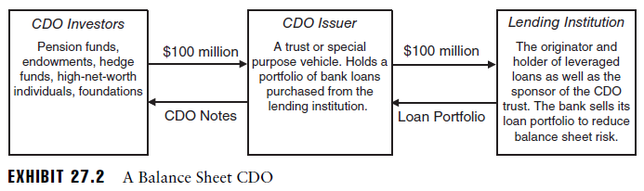

* Discuss the purposes and attributes of arbitrage CDOs

Def **arbitrage** **CDO**: created to attempt to exploit perceived opportunities to earn superior profits through money management

Arbitrage CDO is primarily motivated by a goal of successful selection and management of the CDO’s collateral pool. It is designed to make a profit by capturing a spread for equity investors in CDO and by earning fees for money management services.

Arbitrage profit is earned if the CDO trust can issue its tranches at a yield substantially lower than the yield earned on the bond collateral contained in the trust, such that the equity tranche of the trust receives expected residual income disproportionate to its risk

Another way to view profit motive of an arbitrage CDO in terms of market values instead of spreads and yields. The profit is earned by selling (issuing) securities (tranches) to outside investors at an aggregated price that is higher than that paid for all assets placed into CLO/CBO structure as collateral.

* Describe and apply a typical arbitrage CDO structure

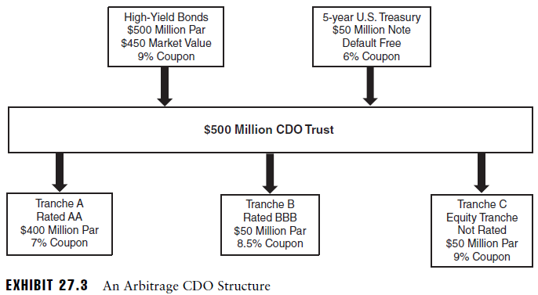

The money manager charges an annual management fee of 50 bps for managing the market value of trust’s assets: 50 bps x $500MM = $2.5MM

In addition, there are annual expenses totaling $1.5MM including fees for trustee to oversee the indenture clauses of CDO notes

The CDO trust also buys a $50MM 5-year US treasury note at annual coupon rate of 6%. The Treasury note is used to provide credit protection to Tranche A and helps allow for AA credit rating to senior tranche, along with diversification and subordination of other tranches. The investor in Tranche A receive a higher yield than given by US Treasuries, as CDO has credit risk and merits a complexity premium.

The second tranche has a face value of %50MM and stated coupon of 8.5% and rated BBB.

The first priority for cash flows from collateral pool is to pay expenses and fees of the trust, including money manager annual fee and total annual expenses

Default losses lower both value of collateral assets and flow of coupon income.

## Demonstrate knowledge of the mechanics of and motivations for arbitrage CDOs

* Identify the three direct financial motivations for a manager of an arbitrage CDO

1. Earn a transaction fee for selling its high-yield portfolio to CDO trust
2. Earn management fees for its money management expense
3. As equity investor in CDO trust, earn spread or arbitrage income from CDO trust between CDO collateral income and payouts on CDO notes

## Demonstrate knowledge of cash-funded CDOs and synthetic CDOs

* Compare and contrast cash-funded CDOs and synthetic CDOs

Another major distinction between CDSs: cash-funded vs synthetic, in addition to B/S vs arbitrage CDOs. Cash-funded CDOs are constructed with an actual sale and transfer to loans or assets to CDO trust, while in a synthetic CDO, the sponsoring bank transfers the risks and returns of a designated basket of loans or other assets via a credit derivative transaction, usually CDS or TRS. Therefore, institution transfer the risk profile associated with its assets, but NOT give up legal ownership of assets, and NOT receive cash from selling asset

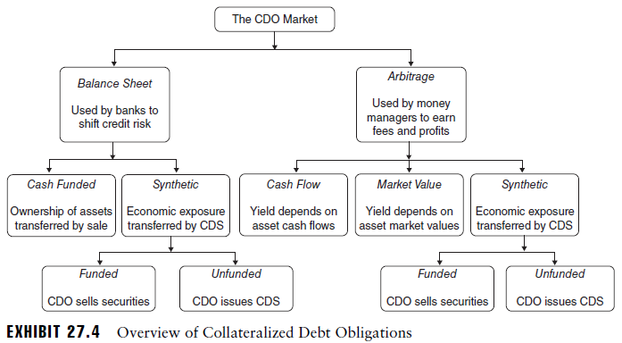

* Explain how a cash-funded CDO can be used to reduce required regulatory capital

A cash-funded CDO involves actual purchase of portfolio of securities serving as collateral for trust and to be held in the trust. Good: used to completely replace risky assets with cash on B/S, rather than synthetically removing only the risk through derivatives

Potential advantages:

1. Reducing risk-based/regulatory capital is the most important motivation for a bank to form a CDO trust. Using a CDO trust to securitize and sell a portfolio of commercial loans can free up regulatory capital that must be committed to support the loan portfolio
2. Sometimes, the equity tranche of CDO trust is not appealing to outside investors and cannot be sold. In this case, the sponsoring bank may have to retain an equity in CDO trust => regulatory requires the bank to maintain risk-based capital equal to its first-loss position.
3. The lending institution receives cash proceeds from sale of its loans to CDO trust, can be used to originate additional commercial loans or to strengthen its B/S. In addition, the selling bank may want to reduce the exposure to one industry.

* Describe the characteristics of synthetic CDOs

The CDO obtains risk exposures for collateral pool through use of a credit derivative, such as CDS and TRS. Physical ownership is NOT transferred to CDO, only the economic exposure. In effect, the CDO trust sells credit protection on a referenced basket of assets. In this case, CDO receives income in form of CDS payments from credit protection buyer.

In most cases, CDO trust collects cash from the sale of the tranche securities and earns interest by investing the cash in low-risk collateral.

There are 3 major potential advantages to synthetic CDOs over cash-funded CDOs

1. Less burdensome than the transfer of assets required for a cash-funded CDO
2. Can be used to provide economic exposure to credit-risky assets that may be relatively scarce and difficult to acquire in the cash market
3. can employ leverage by using derivatives to sell credit protection on assets of a size that is greater than the level of assets in the collateral pool

There are 2 difficulties posed by synthetic CDOs relative to cash-funded CDOs

1. The CDO is exposed to the risk of bankruptcy by counterparties to the credit derivatives at the same time that the credit derivatives have positive market values
2. When the CDO has direct ownership and physical possession of the credit risky collateral assets (cash funded), there are reduced potential legal entanglements than when the CDO has a relationship with an entity through one or more credit derivatives (synthetic)

## Demonstrate knowledge of cash flow and market value CDOs

* Describe the characteristics of cash flow CDOs

Under arbitrage CDO structure, there can be a further subdivision between cash flow CDOs and market value CDOs. The primary distinctions related to the extent to which the assets are selected to match the maturities of liabilities

In cash flow CDO, the proceeds of issuance and sale of securities (tranches) are used to purchase a portfolio of underlying credit-risky assets, with attention paid to matching the maturities of assets and liabilities. Cash inflows are anticipated to be received in time to meet the cash outflows required by tranche holders. The CDO manager should focus on maintaining sufficient credit quality for underlying portfolio such that portfolio can redeem the liabilities issued by CDO

Most arbitrage CDOs are actively managed, meaning after initial CDO portfolio is constructed, the manager of CDO trust can buy and sell bonds that meet CDO trust’s criteria to enhance yield to CDO investors and reduce risk of loss through default

* Describe the characteristics of market value CDOs

The underlying portfolio is actively traded without a focus on cash flow matching of assets and liabilities. The liabilities of CDO are paid off through the trading and sale of underlying portfolio. The manager is most concerned with market value of assets and volatility of those market values. The return earned by investors is linked to the market value of underlying collateral contained in CDO trust

## Demonstrate knowledge of credit risk and enhancement of CDOs

* Define and discuss subordination as an internal credit enhancement

Def internal credit enhancement: protects tranche investors and made within CDO structure, such as large cash position. Generally, credit enhancements are made at the expense of lower coupon rates paid on CDO securities.

Subordination is the most common form of credit enhancement in a CDO transaction, and it flows from structure of CDO trust. It is an internal credit enhancement, the process of protecting a given security by issuing other securities with a lower seniority to cash flows

CDO structure can also be used for collateral assets with little or no credit risk, such as insured mortgages. In these cases, subordination affects the timing of payments to various tranches rather than credit risk of those payments. This sequential payment structure is often referred to as a waterfall.

* Discuss and apply overcollateralization

Overcollateralization refers to excess of assets over a given liability or group of liabilities. Overcollateralization of a senior tranche occurs when there are subordinated tranches in a CDO.

The level of overcollateralization is the ratio of assets available to meet an obligation to the size of obligation and all other obligations senior to that obligation. The overcollateralization rate for senior tranche for example = $100/$70 = 143%

The funds used to purchase the excess collateral come from both of subordinated tranches, plus equity tranches.

Overcollateralization is an internal credit enhancement

* Describe excess spread as an internal credit enhancement

The average coupon on assets may exceed the average coupon on the tranches such that in the absence of default, the CDO should be able to receive more cash than it is required to distribute. The excess spread may come from 1) assets of CDO trust earn a premium of illiquidity; 2) lower credit quality; 3) sloped term structure and mismatched assets and liabilities

* Discuss reserve accounts as a credit enhancement

Def **reserve** **account**: holds excess cash in highly rated instruments, such as US Treasury or high-grade commercial paper, to provide security to debt holders of CDO trust.

It is argued that cash reserves are not the most efficient form of internal credit enhancement, as they generally earn a lower rate of return than required to fund CDO securities

* Describe external credit enhancements to CDOs

Def external credit enhancement: protection to tranche investors that is provided by an outside 3rd party, such as form of insurance against defaults in loan portfolio. The effects is to transfer credit risks associated with CDO trust collateral from holders of CDO trust securities to outside company

## Demonstrate knowledge of new developments in CDOs.

* Describe distressed debt CDOs

Def distressed debt CDO: uses CDO structure to securitize and structure the risks and returns of a portfolio of distressed debt securities, in which the primary collateral component is distressed debt.

The appeal of CDO structure: ability to provide a series of tranches of collateralized securities that can have an investment-grade credit rating, even though the underlying collateral in CDO is mostly distressed debt

CDO securities can receive a higher investment rating than underlying distressed collateral through diversification, subordination and credit enhancements

Historically, Banks are the main suppliers for distressed debt CDOs. Banks is willing to put collateral to distressed debt CDOs

1. Improves bank’s B/S by removing distressed loans and reducing its nonperforming assets
2. Divestiture of distressed debt allows bank to obtain regulatory capital relief by reducing the amount of regulatory capital required to maintain
3. Divestiture provides cash, or liquidity, to the bank

* Describe hedge fund CDOs

Def collateralized fund obligation (CFO): applies CDO structure to ownership of HF as collateral pool. The CDOs of hedge funds facilitate diversification and allow investors to have professional management and reduced difficulties due to min investment sizes.

* Describe single-tranche CDOs

Def single-tranche CDO: highly targeted structure of credit risk exposure.

Vs CDS: single-tranche CDO only transfer a specific slice of portfolio risk to investors, rather than the entire portfolio risk

Single-tranche CDO allow even more customization for an investor, such as collateral composition, maturity of single-tranche note, and weighted average credit rating => Most fine-tuned of any structure => called CDO on demand

## Demonstrate knowledge of the risks of CDOs

* Recognize the risk of the underlying collateral

The risk of underlying collateral is the single greatest driver of risk associated with investment in a CDO structure

* Recognize the financial engineering risk

Def **financial** **engineering** **risk**: potential loss attributable to securitization, structuring of cash flows, option exposures, and other applications of innovative financing devices

* Discuss the implications of high correlations among the underlying assets

CDOs are often called correlation products, as the collateral pool of a CDO can reference numerous assets and the correlations of returns of those assets drive the aggregate risks of the portfolio

* Define risk shifting, and discuss its implications for CDOs

Def **risk** **shifting**: process of altering the risk of an asset or a portfolio in a manner that differentially affects the risk and values of related securities and investors who own those securities.

Equity tranche can be viewed as a call option

Higher risk in collateral asset pool can occur both from higher-risk assets and from higher return correlations among the assets (i.e. reduced diversification)

* Describe how CDO credit risk can be modeled

A copula approach to analyzing the credit risk of a CDO may be viewed like a simulation analysis of the effects of possible default rates on the cash flows to the CDO’s tranches and the values of CDO’s tranches.